Quick Reference Guide—Adding a Degree

This quick reference guide walks applicants through the steps for accurately completing the education section of their application.

1. Effective Date
Enter today’s date in the Effective Date field.


2. Degree Selection
Click the magnifying glass icon to open a new dialog box.
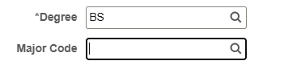

3. Choose Degree Type
Select your degree type from the drop-down menu.
• If the list is not visible, click 'Search Results' to display options.
• Then select your degree type.
Note: This step is for degree type only, not your major.
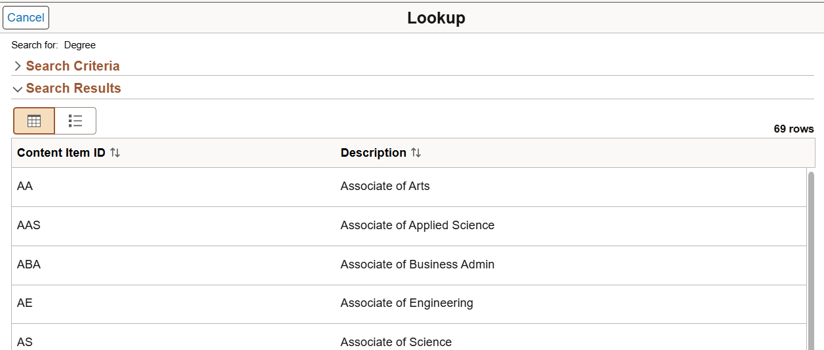

4. Major Code Selection
After selecting your degree type, you will return to the Add Degree section.
Click the magnifying glass next to 'Major Code'.
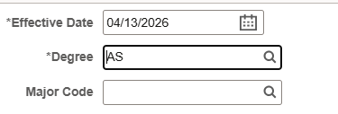

5. Search for Your Major
A new dialog box will open.
• Only the first 300 major codes appear under 'Search Results'.
• If your major is not listed, click 'Search Criteria'.
• In the Description field, type the name of your major.
Tip: If your major has multiple words, try entering just the first word.
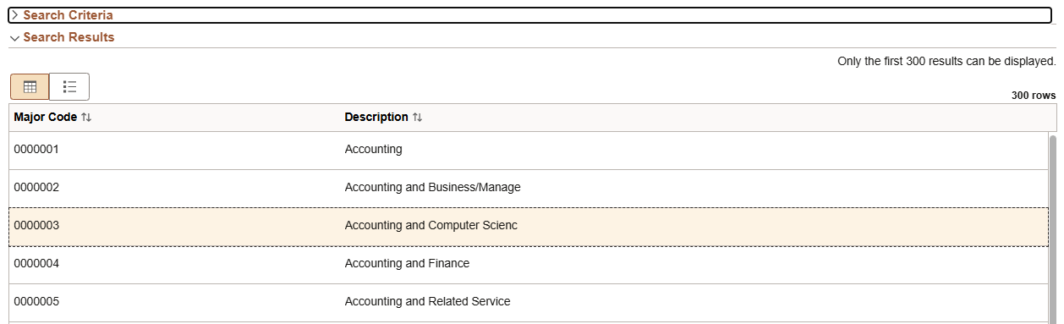
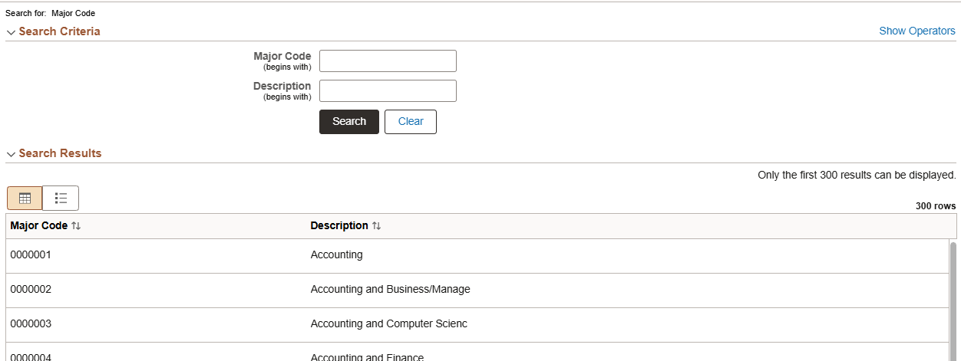
If your major still does not appear:
• Select the closest match OR
• Leave the major field blank.

6. Completing the Remaining Fields
• For any field with a magnifying glass, use it to select an option (do not type manually).
• The following fields should be entered manually:
- GPA
- Minor description (if applicable)
- Year degree was awarded
- School Name
• Check the 'Terminal Degree' box if your degree is the highest level possible (e.g., PhD in Psychology).
